

Best Practices

Concierge Maintenance

Database Backup

The first three rules of safe computing are 1) Backup, 2) Backup and 3) Backup your backup. The Concierge Assistant provides the following feature to assist you with this task.

The Concierge Maintenance Program contains a feature that allows you to create a backup copy of your Concierge Assistant databases. It will not replace a proper backup strategy in your IT Department, yet it does create an additional level of data security.

Please note that ALL users must have Exited The Concierge Assistant program before any maintenance can be done.” (Please refer to our Best Practices document - “Check for Logged On Users”)

When you launch the Concierge Maintenance program the “Copy to;” text box will contain the path to your network Database directory and a file name that is “CA” and today’s date in YMD format. This method is recommended for Systems Administrators.
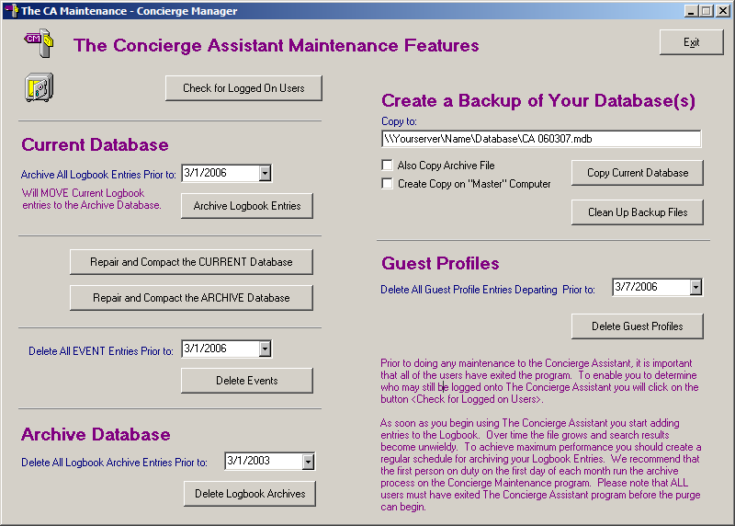

In many properties, only certain “Administrative Users” have the rights to this address and so for many it may not be accessible. We therefore recommend that the Backup maintenance for The Concierge Assistant be performed on the “Master Computer”. (Please refer to our Best Practices- “The Master Computer” to help you create or identify the designated workstation.)

When you are using your “Master Computer” a checkbox will appear below the “Also Copy Archive File” checkbox. If you check this box the path to your local Concierge Assistant installation will appear in place of the network path. Using this method you will have backups of your database in an easily accessible location. This greatly enhances your data security. These backup files may be used in the unlikely event of a database disaster. Call your IT Department or Gold Key Solutions to assist you should you need to restore your database with your backups.

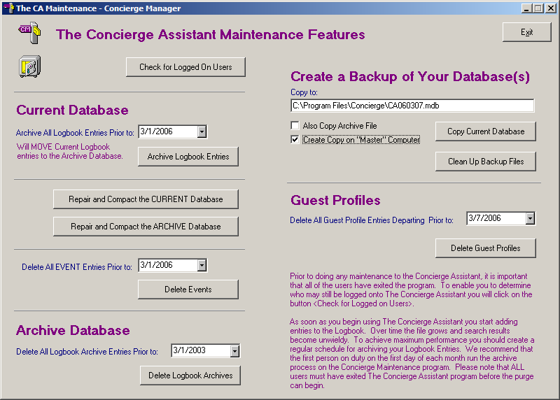

Click on the “Copy Current Database” button. The system will present to you the following:

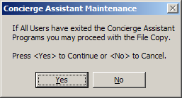

Reminder: All users must EXIT The Concierge Assistant whenever maintenance of any kind is performed. Please check for logged on users before performing this maintenance routine.

Click on the “Yes” button if all users have exited The Concierge Assistant.

Below the text box is a checkbox where you may select to “Also Copy the Archive File”. The archive file only changes when you purge Logbook Entries (see the Best Practices document on Archiving Your Logbook) so we recommend creating a copy of this file monthly, immediately after purging your Logbook. To do this, put a checkmark in the box. The button has now changed to “Copy Both Databases”. Click on this button and follow the instructions.

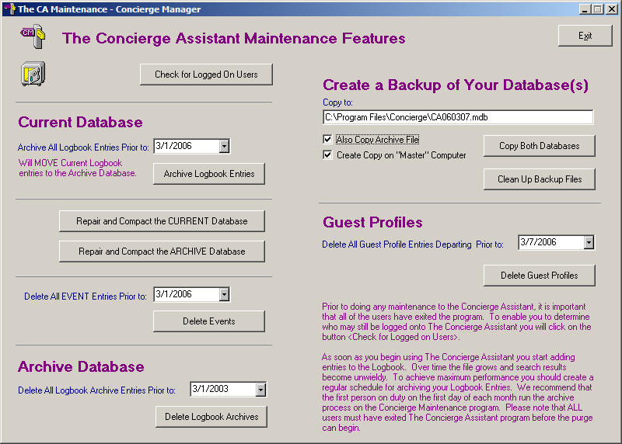

Once you begin Backing Up Your Databases you will need to monitor and clean up your older backup files. The Concierge Assistant provides the following feature to assist you with this task.

Below the “Copy…Database” button you will see another button labeled “Clean Up Backup Files”.
After you have performed the backup copy function, click on the Clean Up Backup Files button.

The following screen will appear:

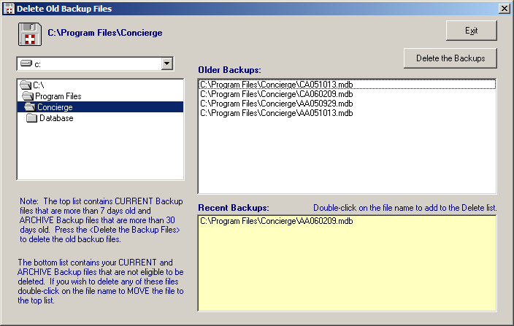

If you are using the “Master Computer” feature, the path to your local Concierge Assistant installation will appear, where you have been backing up your files. The panel will display both the “Older Backups” and the “Recent Backups”. In the Older Backup section, any Daily backed up files that are more than 7 days old and any Archive files that are more than 30 days old will appear and are ready to be deleted. Press the “Delete the Backups” button to delete these files. (If you are a Systems Administrator, you may navigate to the network directory where The Concierge Assistant is installed, to delete those files saved to that directory.)

You may double click on any of the Recent Backups you want to include in the files to be deleted.

The Archive file will become larger over time and the Current file grows during the month until the regular purge is done – it is therefore imperative that you manage your backups and the disk space that they require.

We strongly recommend that you create a backup of your Current database daily. Your Archive database need only be backed-up after you purge your logbook entries. Following these simple steps will help to ensure that you are ready should a disaster strike.

